KBLH-E61规格详细说明

版本说明

版本 | 日期 | 说明 | 备注
V0.1 | 2020.06.22 | 创建并完成首次版本

KBLH-E61规格详细说明
KBLH-E61主板框架图

KBLH-E61详细规格
System
Form Factor | COM Express Basic size, Type 6
CPU | Intel® Core™ 6/7th 45W Platform Processor with PCH HM175
Memory Type | DDR4 SODIMM x 2
Max.Memory Capacity | up to 32 GB
BIOS | AMI BIOS
Watchdog Timer | Yes
Power Requirement | Standard +12V
Power Consumption | -
Dimension | 4.92" x 3.75" (125 mm x 95 mm)
Operating Temperature | -4˚F ~ 158˚F (-20˚C ~ 70˚C)
Storage Temperature | -4˚F ~ 158˚F (-20˚C ~ 70˚C)°
Display
Display Controller | Intel® HD Graphics 630
Video Output | LVDS or eDP, DDI x 3
LVDS Interface | Supports 18-bit and 24-bit Single/Dual channel
I/O
Ethernet | Intel® I219, Gigabit Ethernet
Audio | HD Audio
USB port | USB2.0 x 8, USB3.2 Gen 2 x 4
Serial Port | 2-Wire UART (Tx/Rx) x 2
HDD Interface | SATA 3 x 4
Expansion Slot | PCIe[x16] x 1  PCIe[x1] x 8  I2C  LPC  SMBus
GPIO | 4 x GPI 4 x GPO

KBLH-E61主板框架图

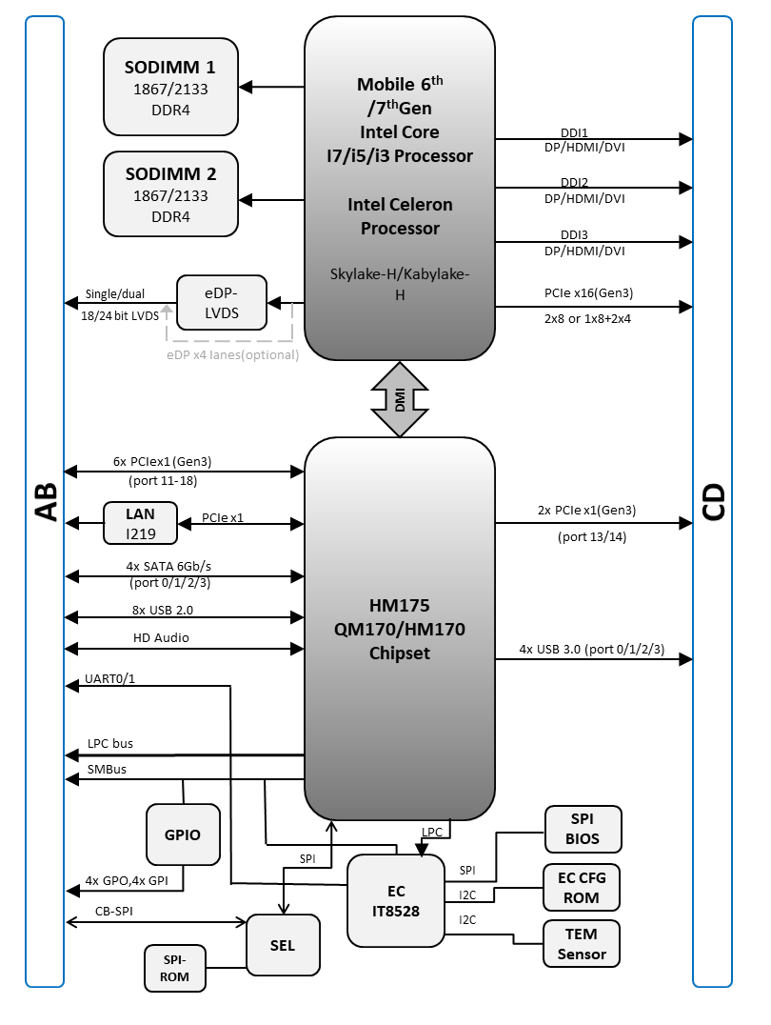

主板布局图
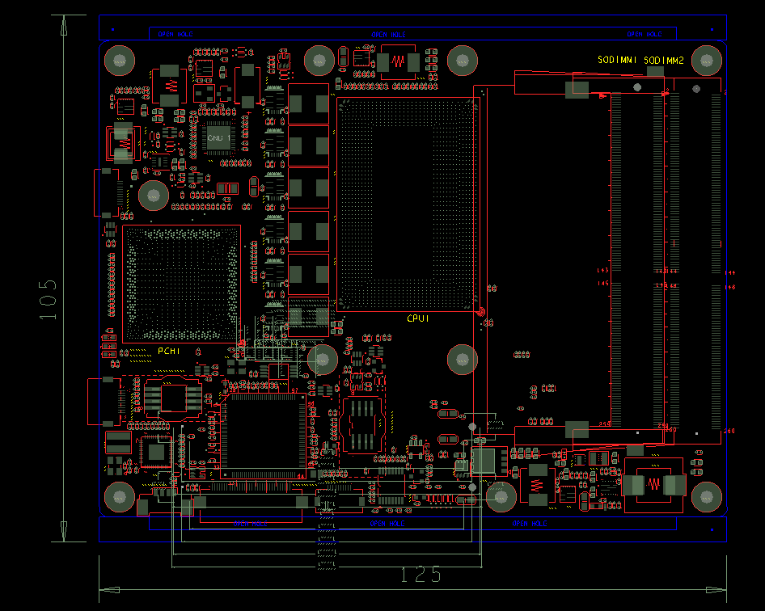
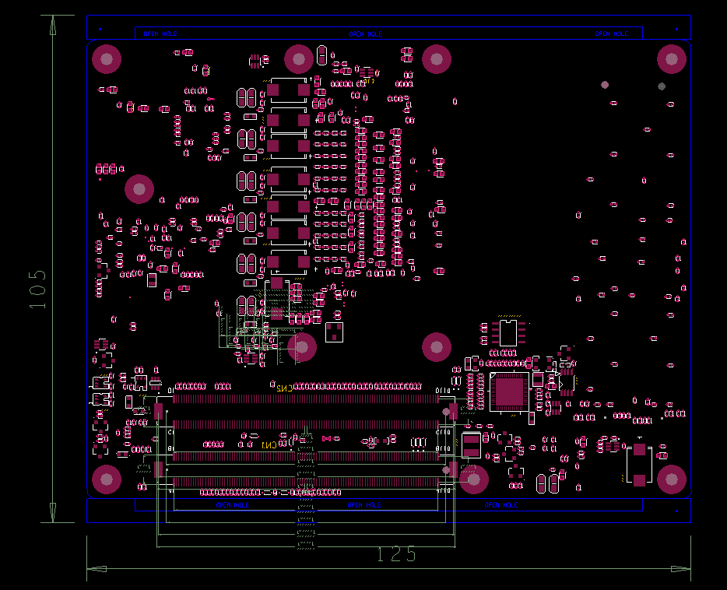

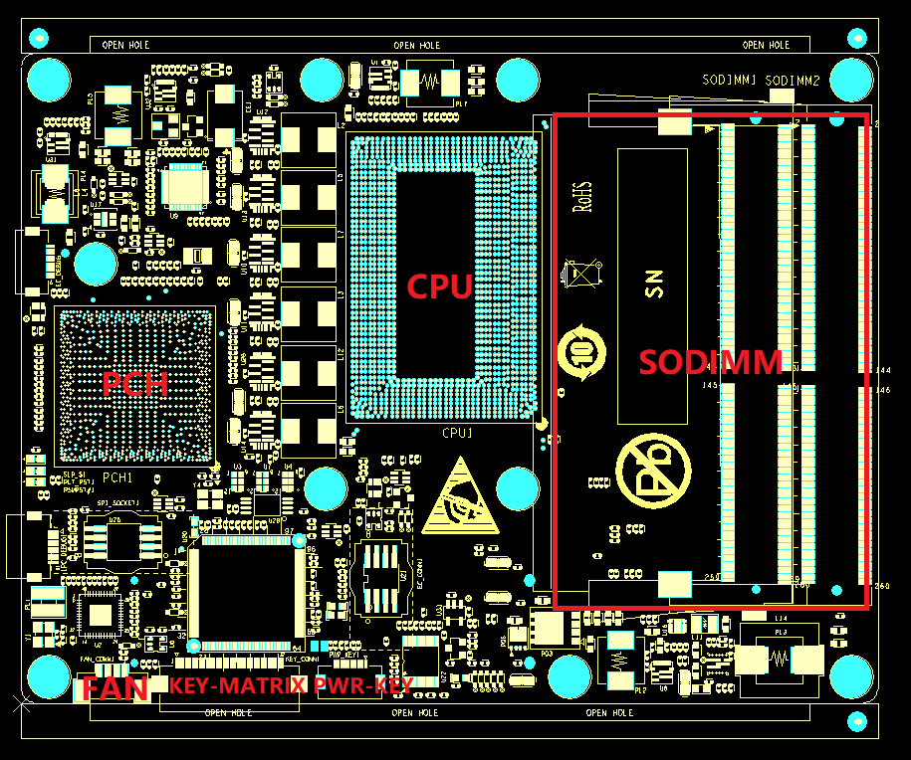
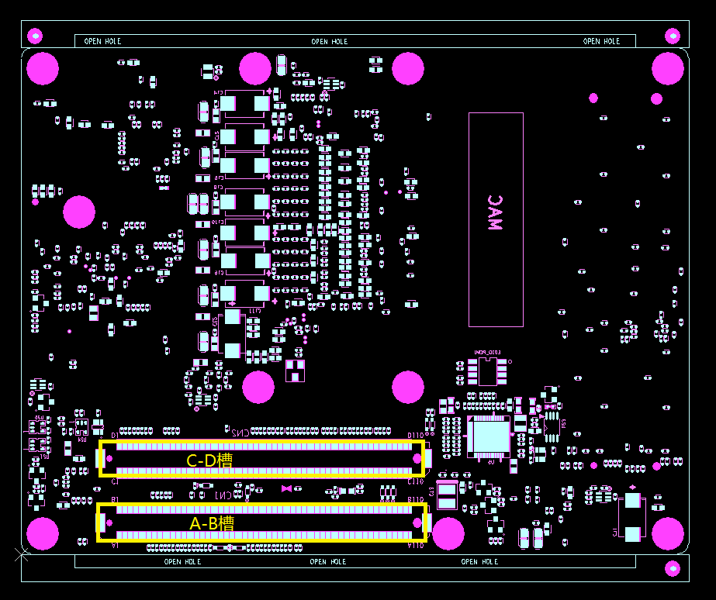

接口PIN 定义
A Role |  |  | B Role
Pin | Name | Description | Pin | Name | Description
A1 | GND (fixed) | GND (fixed) | B1 | GND (fixed) | GND (fixed)
A2 | GBE0_MDI3- | GBE0_MDI3- | B2 | GBE0_ACT# | 网络Active 指示灯，低电平有效
A3 | GBE0_MDI3+ | GBE0_MDI3+ | B3 | LPC_FRAME# | LPC_FRAME#
A4 | GBE0_LINK100# | 100M LINK LED, 低电平有效 | B4 | LPC_AD0 | LPC_AD0
A5 | GBE0_LINK1000# | 1000M LINK LED, 低电平有效 | B5 | LPC_AD1 | LPC_AD1
A6 | GBE0_MDI2- | GBE0_MDI2- | B6 | LPC_AD2 | LPC_AD2
A7 | GBE0_MDI2+ | GBE0_MDI2+ | B7 | LPC_AD3 | LPC_AD3
A8 | GBE0_LINK# | 10M/100M/1000M LINK LED， 低电平有效 | B8 | LPC_DRQ0# | NC
A9 | GBE0_MDI1- | GBE0_MDI1- | B9 | LPC_DRQ1# | NC
A10 | GBE0_MDI1+ | GBE0_MDI1+ | B10 | LPC_CLK | LPC_CLK
A11 | GND (fixed) | GND (fixed) | B11 | GND (fixed) | GND (fixed)
A12 | GBE0_MDI0- | GBE0_MDI0- | B12 | PWRBTN# | 开关按键触发信号，INPUT，低电平脉冲触发有效
A13 | GBE0_MDI0+ | GBE0_MDI0+ | B13 | SMB_CK | SMBUS CLK 信号，SUS电源
A14 | GBE0_CTREF | GBE0_CTREF ，0.1uF电容直接接GND | B14 | SMB_DAT | SMBUS DAT 信号，SUS电源
A15 | SUS_S3# | 电源管理信号，用于指示S3状态，output，低电平有效 | B15 | SMB_ALERT# | SMB_ALERT#
A16 | SATA0_TX+ | SATA0_TX+ | B16 | SATA1_TX+ | SATA1_TX+
A17 | SATA0_TX- | SATA0_TX- | B17 | SATA1_TX- | SATA1_TX-
A18 | SUS_S4# | 电源管理信号，用于指示S4状态，output，低电平有效 | B18 | SUS_STAT# | Suspend指示信号，Output，用于通知LPC 设备
A19 | SATA0_RX+ | SATA0_RX+ | B19 | SATA1_RX+ | SATA1_RX+
A20 | SATA0_RX- | SATA0_RX- | B20 | SATA1_RX- | SATA1_RX-
A21 | GND (fixed) | GND (fixed) | B21 | GND (fixed) | GND (fixed)
A22 | SATA2_TX+ | SATA2_TX+ | B22 | SATA3_TX+ | SATA3_TX+
A23 | SATA2_TX- | SATA2_TX- | B23 | SATA3_TX- | SATA3_TX-
A24 | SUS_S5# | 电源管理信号，用于指示S5状态，output，低电平有效 | B24 | PWR_OK | 底板PWROK信号，用于指示底板的器件供电指示，高电平有效，不用可以悬空。
A25 | SATA2_RX+ | SATA2_RX+ | B25 | SATA3_RX+ | SATA3_RX+
A26 | SATA2_RX- | SATA2_RX- | B26 | SATA3_RX- | SATA3_RX-
A27 | BATLOW# | 电池低电指示信号，INPUT，低电平有效 | B27 | WDT | WDT输出信号，低电平有效，不用可以悬空
A28 | (S)ATA_ACT# | SATA LED指示灯信号，OUTPUT，低电平有效 | B28 | HDA_SDIN2 | HDA_SDIN2
A29 | HDA_SYNC | HDA_SYNC | B29 | HDA_SDIN1 | HDA_SDIN1
A30 | HDA_RST# | HDA_RST# | B30 | HDA_SDIN0 | HDA_SDIN0
A31 | GND (fixed) | GND (fixed) | B31 | GND (fixed) | GND (fixed)
A32 | HDA_BITCLK | HDA_BITCLK | B32 | SPKR | 蜂鸣器Buzzer控制信号，Output，PWM信号
A33 | HDA_SDOUT | HDA_SDOUT | B33 | I2C_CK | EC I2C CLK 信号，上拉到EC电源
A34 | BIOS_DIS0# | Strap PIN，选择核心板BIOS还是载BIOS有效，Input，低电平有效 | B34 | I2C_DAT | EC I2C CLK 信号，上拉到EC电源
A35 | THRMTRIP# | 过热检测信号，Output，低有效 | B35 | THRM# | 过热指示信号，Input，低电平有效，会使CPU降频
A36 | USB6- | USB6- | B36 | USB7- | USB7-
A37 | USB6+ | USB6+ | B37 | USB7+ | USB7+
A38 | USB_6_7_OC# | USB OC功能，Input，低电平有效 | B38 | USB_4_5_OC# | USB OC功能，Input，低电平有效
A39 | USB4- | USB4- | B39 | USB5- | USB5-
A40 | USB4+ | USB4+ | B40 | USB5+ | USB5+
A41 | GND (fixed) | GND (fixed) | B41 | GND (fixed) | GND (fixed)
A42 | USB2- | USB2- | B42 | USB3- | USB3-
A43 | USB2+ | USB2+ | B43 | USB3+ | USB3+
A44 | USB_2_3_OC# | USB OC功能，Input，低电平有效 | B44 | USB_0_1_OC# | USB OC功能，Input，低电平有效
A45 | USB0- | USB0- | B45 | USB1- | USB1-
A46 | USB0+ | USB0+ | B46 | USB1+ | USB1+
A47 | VCC_RTC | RTC Battery 电源输入 | B47 | EXCD1_PERST# | EXCD1_PERST#
A48 | EXCD0_PERST# | EXCD0_PERST# | B48 | EXCD1_CPPE# | EXCD1_CPPE#
A49 | EXCD0_CPPE# | EXCD0_CPPE# | B49 | SYS_RESET# | 用于Reset系统，Input，低电平有效，不用可以悬空
A50 | LPC_SERIRQ | LPC_SERIRQ | B50 | CB_RESET# | 用于系统Reset平台设备，Ouput，低电平有效，不用可以悬空
A51 | GND (fixed) | GND (fixed) | B51 | GND (fixed) | GND (fixed)
A52 | PCIE_TX5+ | PCIE_TX5+ | B52 | PCIE_RX5+ | PCIE_RX5+
A53 | PCIE_TX5- | PCIE_TX5- | B53 | PCIE_RX5- | PCIE_RX5-
A54 | GPI0 | GPI0 | B54 | GPO1 | GPO1
A55 | PCIE_TX4+ | PCIE_TX4+ | B55 | PCIE_RX4+ | PCIE_RX4+
A56 | PCIE_TX4- | PCIE_TX4- | B56 | PCIE_RX4- | PCIE_RX4-
A57 | GND | GND | B57 | GPO2 | GPO2
A58 | PCIE_TX3+ | PCIE_TX3+ | B58 | PCIE_RX3+ | PCIE_RX3+
A59 | PCIE_TX3- | PCIE_TX3- | B59 | PCIE_RX3- | PCIE_RX3-
A60 | GND (fixed) | GND (fixed) | B60 | GND (fixed) | GND (fixed)
A61 | PCIE_TX2+ | PCIE_TX2+ | B61 | PCIE_RX2+ | PCIE_RX2+
A62 | PCIE_TX2- | PCIE_TX2- | B62 | PCIE_RX2- | PCIE_RX2-
A63 | GPI1 | GPI1 | B63 | GPO3 | GPO3
A64 | PCIE_TX1+ | PCIE_TX1+ | B64 | PCIE_RX1+ | PCIE_RX1+
A65 | PCIE_TX1- | PCIE_TX1- | B65 | PCIE_RX1- | PCIE_RX1-
A66 | GND | GND | B66 | WAKE0# | 用于S3，S4状态唤醒主机，Input，低脉冲触发
A67 | GPI2 | GPI2 | B67 | WAKE1# | 用于S3，S4状态唤醒主机，Input，低脉冲触发
A68 | PCIE_TX0+ | PCIE_TX0+ | B68 | PCIE_RX0+ | PCIE_RX0+
A69 | PCIE_TX0- | PCIE_TX0- | B69 | PCIE_RX0- | PCIE_RX0-
A70 | GND (fixed) | GND (fixed) | B70 | GND (fixed) | GND (fixed)
A71 | LVDS_A0+ | LVDS_A0+ | B71 | LVDS_B0+ | LVDS_B0+
A72 | LVDS_A0- | LVDS_A0- | B72 | LVDS_B0- | LVDS_B0-
A73 | LVDS_A1+ | LVDS_A1+ | B73 | LVDS_B1+ | LVDS_B1+
A74 | LVDS_A1- | LVDS_A1- | B74 | LVDS_B1- | LVDS_B1-
A75 | LVDS_A2+ | LVDS_A2+ | B75 | LVDS_B2+ | LVDS_B2+
A76 | LVDS_A2- | LVDS_A2- | B76 | LVDS_B2- | LVDS_B2-
A77 | LVDS_VDD_EN | LVDS 逻辑电源使能，Input，高电平有效 | B77 | LVDS_B3+ | LVDS_B3+
A78 | LVDS_A3+ | LVDS_A3+ | B78 | LVDS_B3- | LVDS_B3-
A79 | LVDS_A3- | LVDS_A3- | B79 | LVDS_BKLT_EN | LVDS背光开启信号，Output，高有效
A80 | GND (fixed) | GND (fixed) | B80 | GND (fixed) | GND (fixed)
A81 | LVDS_A_CK+ | LVDS_A_CK+ | B81 | LVDS_B_CK+ | LVDS_B_CK+
A82 | LVDS_A_CK- | LVDS_A_CK- | B82 | LVDS_B_CK- | LVDS_B_CK-
A83 | LVDS_I2C_CK | LVDS_I2C_CK | B83 | LVDS_BKLT_CTRL | LVDS背光调节信号,Output，PWM信号
A84 | LVDS_I2C_DAT | LVDS_I2C_DAT | B84 | VCC_5V_SBY | VCC_5V_SBY
A85 | GPI3 | GPI3，Input，默认高电平 | B85 | VCC_5V_SBY | VCC_5V_SBY
A86 | RSVD | NC | B86 | VCC_5V_SBY | VCC_5V_SBY
A87 | eDP-HPD | eDP-HPD信号，高有效 | B87 | VCC_5V_SBY | VCC_5V_SBY
A88 | PCIE_CLK+ | PCIE_CLK+ | B88 | BIOS_DIS1# | Strap PIN，选择核心板BIOS还是载BIOS有效，Input，低电平有效
A89 | PCIE_CLK- | PCIE_CLK- | B89 | EC_PWM1 | EC GPIO信号，详细使用，见其他文档
A90 | GND (fixed) | GND (fixed) | B90 | GND (fixed) | GND (fixed)
A91 | SPI_POWER | SPI_POWER， 3.3V电平 | B91 | EC_PWM6 | EC GPIO信号，详细使用，见其他文档
A92 | SPI_MISO | SPI_MISO | B92 | EC_PWM7 | EC GPIO信号，详细使用，见其他文档
A93 | GPO0 | GPO0 | B93 |  | NC
A94 | SPI_CLK | SPI_CLK | B94 |  | NC
A95 | SPI_MOSI | SPI_MOSI | B95 | BATT1_ECIN# | EC GPIO信号，详细使用，见其他文档
A96 | TPM_PP | NC | B96 |  | NC
A97 | TYPE10# | NC | B97 | SPI_CS# | SPI_CS#
A98 | SER0_TX | 核心板Uart TX信号 | B98 | PCIE1-4_SATA_PCIE | PCIE1-4_SATA_PCIE
A99 | SER0_RX | 核心板Uart RX信号 | B99 | SATA0-1_SATA_PCIE | SATA0-1_SATA_PCIE
A101 | SER1_TX | 核心板Uart TX信号 | B101 | FAN_PWMOUT | 风扇PWM控制信号，Output
A102 | SER1_RX | 核心板Uart RX信号 | B102 | FAN_TACHIN | 风扇转速信号，Input
A103 | LID# | LID 信号输入，低电平有效 | B103 | SLEEP# | 睡眠控制信号，Input，低脉冲则触发进入睡眠动作。
A104 | VCC_12V | VCC_12V | B104 | VCC_12V | VCC_12V
A105 | VCC_12V | VCC_12V | B105 | VCC_12V | VCC_12V
A106 | VCC_12V | VCC_12V | B106 | VCC_12V | VCC_12V
A107 | VCC_12V | VCC_12V | B107 | VCC_12V | VCC_12V
A108 | VCC_12V | VCC_12V | B108 | VCC_12V | VCC_12V
A109 | VCC_12V | VCC_12V | B109 | VCC_12V | VCC_12V
A110 | GND (fixed) | GND (fixed) | B110 | GND (fixed) | GND (fixed)

C Role |  |  | D Role
Pin | Name |  | Pin | Name
C1 | GND (fixed) | GND (fixed) | D1 | GND (fixed) | GND (fixed)
C2 | GND | GND | D2 | GND | GND
C3 | USB_SSRX0- | USB_SSRX0- | D3 | USB_SSTX0- | USB_SSTX0-
C4 | USB_SSRX0+ | USB_SSRX0+ | D4 | USB_SSTX0+ | USB_SSTX0+
C5 | GND | GND | D5 | GND | GND
C6 | USB_SSRX1- | USB_SSRX1- | D6 | USB_SSTX1- | USB_SSTX1-
C7 | USB_SSRX1+ | USB_SSRX1+ | D7 | USB_SSTX1+ | USB_SSTX1+
C8 | GND | GND | D8 | GND | GND
C9 | USB_SSRX2- | USB_SSRX2- | D9 | USB_SSTX2- | USB_SSTX2-
C10 | USB_SSRX2+ | USB_SSRX2+ | D10 | USB_SSTX2+ | USB_SSTX2+
C11 | GND (fixed) | GND (fixed) | D11 | GND (fixed) | GND (fixed)
C12 | USB_SSRX3- | USB_SSRX3- | D12 | USB_SSTX3- | USB_SSTX3-
C13 | USB_SSRX3+ | USB_SSRX3+ | D13 | USB_SSTX3+ | USB_SSTX3+
C14 | GND | GND | D14 | GND | GND
C15 | DDI1_PAIR6+ | NC | D15 | DDI1_CTRLCLK_AUX+ | DDI1_CTRLCLK_AUX+
C16 | DDI1_PAIR6- | NC | D16 | DDI1_CTRLDATA_AUX | DDI1_CTRLDATA_AUX
C17 | RSVD | NC | D17 | EC_PS2DAT1 | EC_PS2DAT1
C18 | RSVD | NC | D18 | EC_PS2CLK1 | EC_PS2CLK1
C19 | PCIE_RX6+ | PCIE_RX6+ | D19 | PCIE_TX6+ | PCIE_TX6+
C20 | PCIE_RX6- | PCIE_RX6- | D20 | PCIE_TX6- | PCIE_TX6-
C21 | GND (fixed) | GND (fixed) | D21 | GND (fixed) | GND (fixed)
C22 | PCIE_RX7+ | PCIE_RX7+ | D22 | PCIE_TX7+ | PCIE_TX7+
C23 | PCIE_RX7- | PCIE_RX7- | D23 | PCIE_TX7- | PCIE_TX7-
C24 | DDI1_HPD | DDI1_HPD | D24 | EC_PS2DAT0 | EC_PS2DAT0
C25 | DDI1_PAIR4+ | NC | D25 | EC_PS2CLK0 | EC_PS2CLK0
C26 | DDI1_PAIR4- | NC | D26 | DDI1_PAIR0+ | DDI1_PAIR0+
C27 | RSVD | NC | D27 | DDI1_PAIR0- | DDI1_PAIR0-
C28 | RSVD | NC | D28 | RSVD | NC
C29 | DDI1_PAIR5+ | NC | D29 | DDI1_PAIR1+ | DDI1_PAIR1+
C30 | DDI1_PAIR5- | NC | D30 | DDI1_PAIR1- | DDI1_PAIR1-
C31 | GND (fixed) | GND (fixed) | D31 | GND (fixed) | GND (fixed)
C32 | DDI2_CTRLCLK_AUX+ | DDI2_CTRLCLK_AUX+ | D32 | DDI1_PAIR2+ | DDI1_PAIR2+
C33 | DDI2_CTRLDATA_AUX- | DDI2_CTRLDATA_AUX- | D33 | DDI1_PAIR2- | DDI1_PAIR2-
C34 | DDI2_DDC_AUX_SEL | DDI HDMI/DP功能选择PIN，H=HDMI，L=0 （DP） | D34 | DDI1_DDC_AUX_SEL | DDI HDMI/DP功能选择PIN，H=HDMI，L=0 （DP）
C35 | RSVD | NC | D35 | RSVD | NC
C36 | DDI3_CTRLCLK_AUX+ | DDI3_CTRLCLK_AUX+ | D36 | DDI1_PAIR3+ | DDI1_PAIR3+
C37 | DDI3_CTRLDATA_AUX- | DDI3_CTRLDATA_AUX- | D37 | DDI1_PAIR3- | DDI1_PAIR3-
C38 | DDI3_DDC_AUX_SEL | DDI HDMI/DP功能选择PIN，H=HDMI，L=0 （DP） | D38 | RSVD | NC
C39 | DDI3_PAIR0+ | DDI3_PAIR0+ | D39 | DDI2_PAIR0+ | DDI2_PAIR0+
C40 | DDI3_PAIR0- | DDI3_PAIR0- | D40 | DDI2_PAIR0- | DDI2_PAIR0-
C41 | GND (fixed) | GND (fixed) | D41 | GND (fixed) | GND (fixed)
C42 | DDI3_PAIR1+ | DDI3_PAIR1+ | D42 | DDI2_PAIR1+ | DDI2_PAIR1+
C43 | DDI3_PAIR1- | DDI3_PAIR1- | D43 | DDI2_PAIR1- | DDI2_PAIR1-
C44 | DDI3_HPD | DDI3_HPD | D44 | DDI2_HPD | DDI2_HPD
C45 | RSVD | NC | D45 | RSVD | NC
C46 | DDI3_PAIR2+ | DDI3_PAIR2+ | D46 | DDI2_PAIR2+ | DDI2_PAIR2+
C47 | DDI3_PAIR2- | DDI3_PAIR2- | D47 | DDI2_PAIR2- | DDI2_PAIR2-
C48 | RSVD | NC | D48 | RSVD | NC
C49 | DDI3_PAIR3+ | DDI3_PAIR3+ | D49 | DDI2_PAIR3+ | DDI2_PAIR3+
C50 | DDI3_PAIR3- | DDI3_PAIR3- | D50 | DDI2_PAIR3- | DDI2_PAIR3-
C51 | GND (fixed) | GND (fixed) | D51 | GND (fixed) | GND (fixed)
C52 | PEG_RX0+ | PEG_RX0+ | D52 | PEG_TX0+ | PEG_TX0+
C53 | PEG_RX0- | PEG_RX0- | D53 | PEG_TX0- | PEG_TX0-
C54 | TYPE0# | NC | D54 | COM_PEG_RSV# | PEG总线Lane 反向功能选择，Input，默认正向，低电平反向
C55 | PEG_RX1+ | PEG_RX1+ | D55 | PEG_TX1+ | PEG_TX1+
C56 | PEG_RX1- | PEG_RX1- | D56 | PEG_TX1- | PEG_TX1-
C57 | TYPE1# | NC | D57 | TYPE2# | GND
C58 | PEG_RX2+ | PEG_RX2+ | D58 | PEG_TX2+ | PEG_TX2+
C59 | PEG_RX2- | PEG_RX2- | D59 | PEG_TX2- | PEG_TX2-
C60 | GND (fixed) | GND (fixed) | D60 | GND (fixed) | GND (fixed)
C61 | PEG_RX3+ | PEG_RX3+ | D61 | PEG_TX3+ | PEG_TX3+
C62 | PEG_RX3- | PEG_RX3- | D62 | PEG_TX3- | PEG_TX3-
C63 | RSVD | NC | D63 | RSVD | NC
C64 | RSVD | NC | D64 | RSVD | NC
C65 | PEG_RX4+ | PEG_RX4+ | D65 | PEG_TX4+ | PEG_TX4+
C66 | PEG_RX4- | PEG_RX4- | D66 | PEG_TX4- | PEG_TX4-
C67 | RSVD | RSVD | D67 | GND | GND
C68 | PEG_RX5+ | PEG_RX5+ | D68 | PEG_TX5+ | PEG_TX5+
C69 | PEG_RX5- | PEG_RX5- | D69 | PEG_TX5- | PEG_TX5-
C70 | GND (fixed) | GND (fixed) | D70 | GND (fixed) | GND (fixed)
C71 | PEG_RX6+ | PEG_RX6+ | D71 | PEG_TX6+ | PEG_TX6+
C72 | PEG_RX6- | PEG_RX6- | D72 | PEG_TX6- | PEG_TX6-
C73 | GND | GND | D73 | GND | GND
C74 | PEG_RX7+ | PEG_RX7+ | D74 | PEG_TX7+ | PEG_TX7+
C75 | PEG_RX7- | PEG_RX7- | D75 | PEG_TX7- | PEG_TX7-
C76 | GND | GND | D76 | GND | GND
C77 | RSVD | NC | D77 | RSVD | NC
C78 | PEG_RX8+ | PEG_RX8+ | D78 | PEG_TX8+ | PEG_TX8+
C79 | PEG_RX8- | PEG_RX8- | D79 | PEG_TX8- | PEG_TX8-
C80 |  |  | D80 | GND (fixed) | GND (fixed)
C81 | PEG_RX9+ | PEG_RX9+ | D81 | PEG_TX9+ | PEG_TX9+
C82 | PEG_RX9- | PEG_RX9- | D82 | PEG_TX9- | PEG_TX9-
C83 | RSVD | NC | D83 | RSVD | NC
C84 | GND | GND | D84 | GND | GND
C85 | PEG_RX10+ | PEG_RX10+ | D85 | PEG_TX10+ | PEG_TX10+
C86 | PEG_RX10- | PEG_RX10- | D86 | PEG_TX10- | PEG_TX10-
C87 | GND | GND | D87 | GND | GND
C88 | PEG_RX11+ | PEG_RX11+ | D88 | PEG_TX11+ | PEG_TX11+
C89 | PEG_RX11- | PEG_RX11- | D89 | PEG_TX11- | PEG_TX11-
C90 | GND (fixed) | GND (fixed) | D90 | GND (fixed) | GND (fixed)
C91 | PEG_RX12+ | PEG_RX12+ | D91 | PEG_TX12+ | PEG_TX12+
C92 | PEG_RX12- | PEG_RX12- | D92 | PEG_TX12- | PEG_TX12-
C93 | GND | GND | D93 | GND | GND
C94 | PEG_RX13+ | PEG_RX13+ | D94 | PEG_TX13+ | PEG_TX13+
C95 | PEG_RX13- | PEG_RX13- | D95 | PEG_TX13- | PEG_TX13-
C96 | GND | GND | D96 | GND | GND
C97 | RSVD | RSVD | D97 | RSVD | RSVD
C98 | PEG_RX14+ | PEG_RX14+ | D98 | PEG_TX14+ | PEG_TX14+
C99 | PEG_RX14- | PEG_RX14- | D99 | PEG_TX14- | PEG_TX14-
C100 | GND (fixed) | GND (fixed) | D100 | GND (fixed) | GND (fixed)
C101 | PEG_RX15+ | PEG_RX15+ | D101 | PEG_TX15+ | PEG_TX15+
C102 | PEG_RX15- | PEG_RX15- | D102 | PEG_TX15- | PEG_TX15-
C103 | GND | GND | D103 | GND | GND
C104 | VCC_12V | VCC_12V | D104 | VCC_12V | VCC_12V
C105 | VCC_12V | VCC_12V | D105 | VCC_12V | VCC_12V
C106 | VCC_12V | VCC_12V | D106 | VCC_12V | VCC_12V
C107 | VCC_12V | VCC_12V | D107 | VCC_12V | VCC_12V
C108 | VCC_12V | VCC_12V | D108 | VCC_12V | VCC_12V
C109 | VCC_12V | VCC_12V | D109 | VCC_12V | VCC_12V
C110 | GND (fixed) | GND (fixed) | D110 | GND (fixed) | GND (fixed)

结构信息

核心板连接器确认：
BTB Socket 220PIN 0.5mm间距 高度=5mm或者高度=8mm SMT receptacle

Sources for the individual 220-pin receptacle are
Tyco Electronics 3-6318490-6
Foxconn QT012206-1031-2H
ept19
or equivalent 0.5 mm pitch Free Height 220 pin 4H Receptacle

Sources for the combined 440-pin receptacle are:
Tyco Electronics 3-1827231-6
Foxconn QT012206-1041-3H
ept19
or equivalent 0.5mm pitch Free Height 440 pin 4H Receptacle

载板连接器确认：
BTB Socket 220PIN 0.5mm间距 高度=5mm或者高度=8mm SMT plug
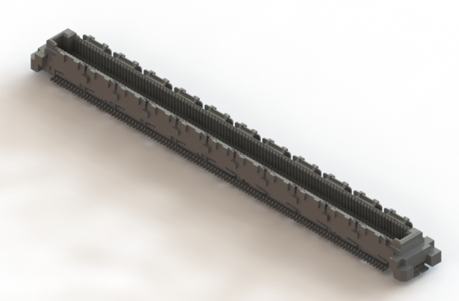

①5mm高度BTB 连接器：
推荐Foxconn QT002206-2131-3H H=5mm

②8mm 高度BTB 连接器：
推荐Foxconn QT002206-4141-3H H=8mm

